**BAHRIA UNIVERSITY (KARACHI CAMPUS**)

**Computing Fundamentals (CSC - 110)**

**Assignment 02**

**Fall 2022**

**Class: BSE 1B Shift: Morning**

**Course Instructor: ENGR. MAHAWISH Submission: 2 Dec 2022**

**Date: 26 Nov 2022 Marks: 05 Points**

**Student Name: ABDULLAH Registration #: 02131222099**



**[CLO-3]**

**Question no. 01 [5 Marks]**

Perform the following logical operations justify through truth tables and draw circuit diagrams.

* (A AND B)
* NOT (A XOR B)
* NOT(A) OR NOT(B)
* C XOR (A OR B)
* {(A NAND B) XNOR (C AND D)}

**Solution:**

* (A AND B):

***Truth Table:***

|  |  |  |
| --- | --- | --- |
| *Input A* | *Input B* | *Output A AND B* |
| 0 | 0 | 0 |
| 1 | 0 | 0 |
| 0 | 1 | 0 |
| 1 | 1 | 1 |

***Circuit Diagram:***

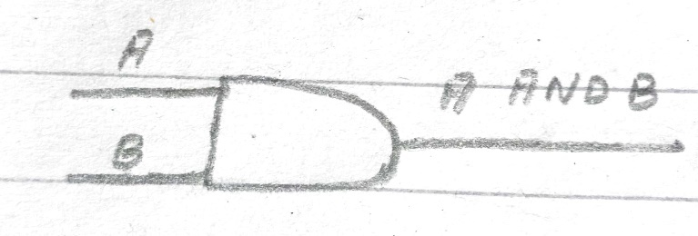

* NOT (A XOR B):

***For A XOR B***

***Truth Table:***

|  |  |  |
| --- | --- | --- |
| *Input A* | *Input B* | *Output A XOR B* |
| 0 | 0 | 0 |
| 1 | 0 | 1 |
| 0 | 1 | 1 |
| 1 | 1 | 0 |

***Circuit Diagram:***

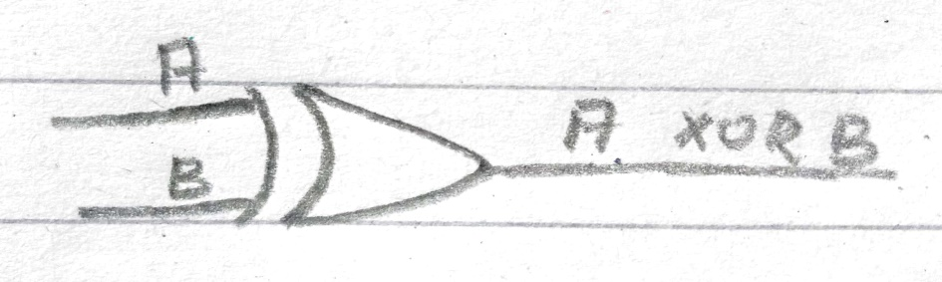

***Now For NOT (A XOR B)***

***Truth Table:***

|  |  |
| --- | --- |
| *Input (A XOR B)* | *Output NOT (A XOR B)* |
| 0 | 1 |
| 1 | 0 |
| 1 | 0 |
| 0 | 1 |

***Circuit Diagram:***

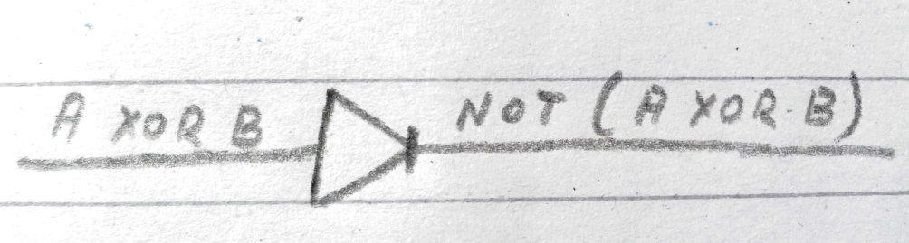

* NOT(A) OR NOT(B):

***For NOT (A)***

***Truth Table:***

|  |  |
| --- | --- |
| *Input (A)* | *Output NOT (A)* |
| 0 | 1 |
| 1 | 0 |

***Circuit Diagram:***

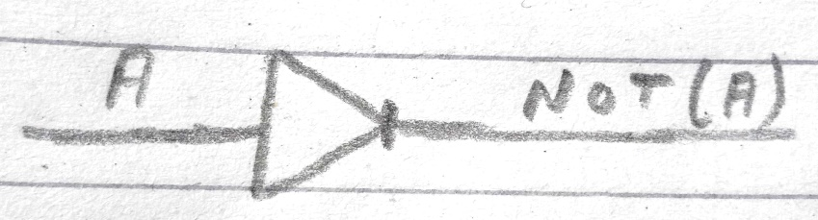

***For NOT (B)***

***Truth Table:***

|  |  |
| --- | --- |
| *Input (B)* | *Output NOT (B)* |
| 0 | 1 |
| 1 | 0 |

***Circuit Diagram:***

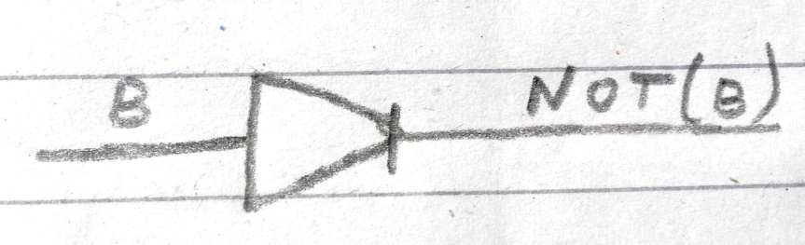

***For NOT (A) OR NOT (B)***

***Truth Table:***

|  |  |  |
| --- | --- | --- |
| *Input NOT (A)* | *Input NOT (B)* | *Output NOT (A) OR NOT (B)* |
| 1 | 1 | 1 |
| 0 | 0 | 0 |

***Circuit Diagram:***

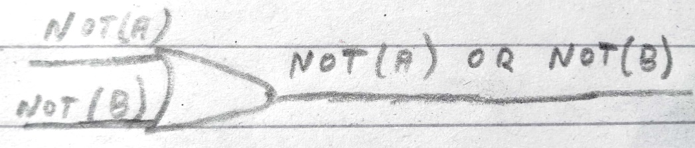

* C XOR (A OR B):

***For (A OR B)***

***Truth Table:***

|  |  |  |
| --- | --- | --- |
| *Input A* | *Input B* | *Output A OR B* |
| 0 | 0 | 0 |
| 1 | 0 | 1 |
| 0 | 1 | 1 |
| 1 | 1 | 1 |

***Circuit Diagram:***

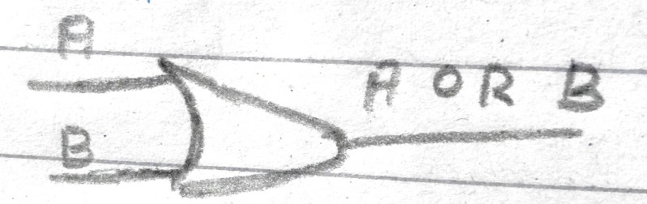

***For C XOR (A OR B)***

***Truth Table:***

|  |  |  |
| --- | --- | --- |
| *Input (A OR B)* | *Input C* | *Output C XOR (A OR B)* |
| 0 | 0 | 0 |
| 1 | 1 | 0 |
| 1 | 0 | 1 |

***Circuit Diagram:***

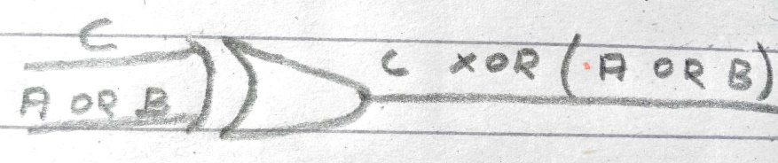

* {(A NAND B) XNOR (C AND D)}:

***For (A NAND B)***

***Truth Table:***

|  |  |  |
| --- | --- | --- |
| *Input A* | *Input B* | *Output A NAND B* |
| 0 | 0 | 1 |
| 1 | 0 | 1 |
| 0 | 1 | 1 |
| 1 | 1 | 0 |

***Circuit Diagram:***

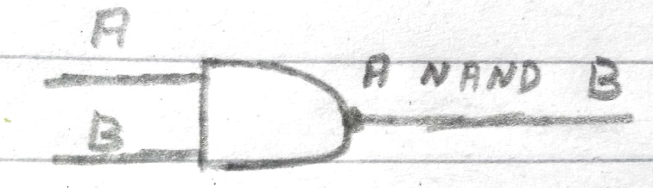

***For (C AND D)***

***Truth Table:***

|  |  |  |
| --- | --- | --- |
| *Input C* | *Input D* | *Output C AND D* |
| 0 | 0 | 0 |
| 1 | 0 | 0 |
| 0 | 1 | 0 |
| 1 | 1 | 1 |

***Circuit Diagram:***

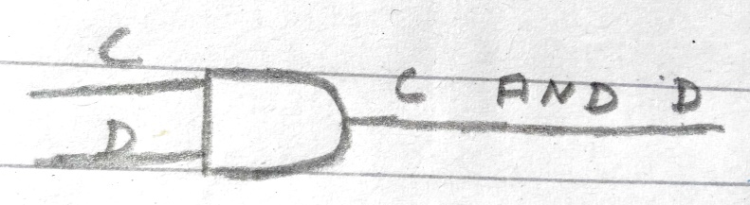

***For {(A NAND B) XNOR (C AND D)}***

***Truth Table:***

|  |  |  |
| --- | --- | --- |
| *Input (A NAND B)* | *Input (C AND D)* | *Output {(A NAND B) XNOR (C AND D)}* |
| 1 | 0 | 0 |
| 1 | 0 | 0 |
| 1 | 0 | 0 |
| 0 | 1 | 0 |

***Circuit Diagram:***

